Stop attacking danger zone using ultrasonic

Introduction

My project “stop attacking danger zone using ultrasonic” is project which help us to stop people or even animal for stop attacking danger zone by blinking and making sound that will help to stop attacking.

My project will use electronic component like buzzer, ultrasonic, resistance, led and Arduino uno

Problem statement

In many industries accident occur due man power who didn’t know to read and negligence of many workers to follow sign.

My project will be facing about accident occur in many industries due to many reasons below:

Will help us to guide people who didn’t know to read or other one who negligence to read, so when led start to blink with buzzer people will know that there is something wrong.

Will help us to guide blind person due to sound of buzzer blind persons will stop to attack danger zone.

This system speeds up information compared with using sign due blinking of led and sound of buzzer.

Component used

Ultrasonic: is sensor for detect object

Breadboard: used for connecting devices

LED: for blinking after detection of sensor

Resistors: for protecting led

Buzzer: for making sound

Arduino uno

**connection**

1. BUZZER: a) positive terminal (+) - pin 6
2. b) negative terminal (-) -pin GND.
3. ULTRASONIC: a) pin GND - pin GND to the Arduino board.
4. b) pin ECHO - pin 2.
5. c) pin TRIG - pin 3.
6. d) pin VCC - 5V supply.

Code

const int led1=4;

const int led2=5;

const int enchopin=2;

const int trigpin=3;

const int buzzerpin=6;

long nduration;

int ndistance=20;

void setup()

{

pinMode(led1,OUTPUT);

pinMode(led2,OUTPUT);

pinMode(trigpin,OUTPUT);

pinMode(enchopin,INPUT);

pinMode(buzzerpin,OUTPUT);

Serial.begin(9600);

Serial.println("starting ultrasonic detector...");

}

void loop()

{

digitalWrite(trigpin,HIGH);

delayMicroseconds(20);

digitalWrite(trigpin,LOW);

delayMicroseconds(10);

digitalWrite(trigpin,LOW);

nduration=pulseIn(enchopin,HIGH);

ndistance=0.034*(nduration/2);

Serial.print(ndistance);

Serial.println("cm");

if(ndistance<8)

{

digitalWrite(buzzerpin,HIGH);

delay(100);

}

else

{

noTone(buzzerpin);

delay(30);

}

if(ndistance<15)

{

digitalWrite(led1,HIGH);

delay(200);

}

else

{

digitalWrite(led1,LOW);

delay(100);

}

if(ndistance<30)

{

digitalWrite(led2,HIGH);

delay(400);

}

else

{

digitalWrite(led2,LOW);

delay(200);

}

}

Fritzing

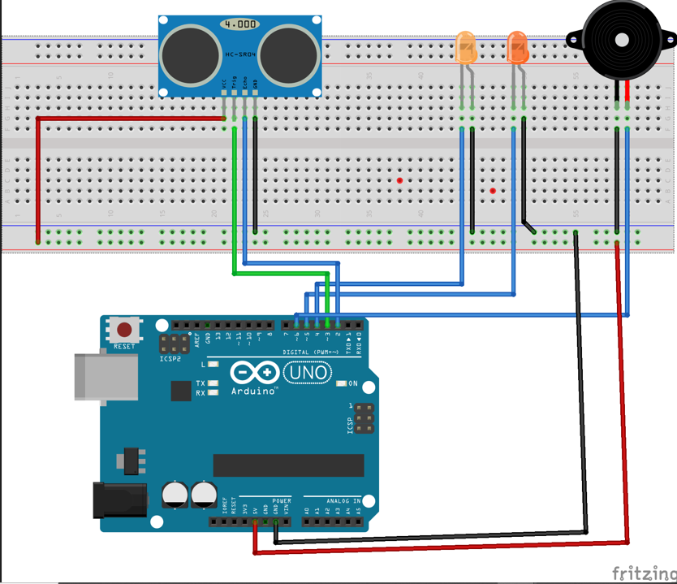

Working principle

This circuit has 2led, ultrasonic, buzzer, breadboard, 2 resistors, and Arduino uno.

Led will brinks due to detection of ultrasonic but they will blink according to the distance you set.

1st led will start to blink its self in 30cm and 2nd led will blink in 15cm with 1st led and in 8cm buzzer will turn on with all led.

Conclusion

This project will help us to decrease accident in industries according its working compered to system of using sign because when led blink with buzzer every on start to think what wrong